PRESS RELEASE

COMMUNICATIONS AND MEDIA TEAM OF THE 2023 ASEAN SUMMIT

No. 07/SP/TKM-ASEAN2023/ENG/4/2023

Hotels, Restaurants Association Committed to Providing Excellent Service to ASEAN Summit Participants

West Manggarai, 29 April 2023 – Indonesian Hotels and Restaurants Association (PHRI) West Manggarai chapter is committed to providing excellent service to the participants of the 42nd ASEAN Summit in Labuan Bajo, West Manggarai, East Nusa Tenggara.

"PHRI will give the best service to the ASEAN Summit delegates," said PHRI West Manggarai chapter secretary Irene Tokan in Labuan Bajo, West Manggarai, Saturday, 29 April.

ASEAN heads of state and delegates will attend the 42nd ASEAN Summit that will take place from 9 to 11 May.

The ASEAN Summit delegates will stay at several star-rated hotels in Labuan Bajo.

Irene underscored PHRI is committed to providing excellent service to the guests who attend the international event.

The staff had been trained to serve special guests with excellent service. Each hotel also ensured cleanliness in all areas so that the guests of the delegation get comfort during their stay at the venue.

PHRI also continues to carry out its duty, particularly, in hospitality supervision so that services provided to guests are in accordance with the operational standards of service.

Irene is optimistic about the three-day international event bringing in thousands of people.

The guests are like a breath of fresh air for the tourism business development in Labuan Bajo as a super-priority tourism destination.

Irene hopes West Manggarai will be known by the world and become a pride for Indonesia through this event.

She also hopes ASEAN Summit becomes a tourism promotion event so that the guests return to Labuan Bajo with family and relatives in the future.

"Labuan Bajo is ready to welcome the guests," she said optimistically.

Labuan Bajo Flores Tourism Authority (BPOLBF) reported the qualified 1,156 rooms from 22 hotels and resorts in Labuan Bajo had been designated as accommodations for the 42nd ASEAN Summit delegates and the national committee.

Distribution of hotels for ASEAN Summit participants is done centrally or one door through the State Secretariat Ministry and BPOLBF as a local committee.

The rooms are provided by five five-star hotels and resorts, five four-star hotels and resorts, five three-star hotels and resorts, and six two-star hotels and resorts.

The hotel occupancy rate from 9 to 11 May is at 100 percent. (Fransisca/TR/Elvira)

***

For more information, please contact:

Director General of Public Information and Communications of the Ministry of Communications and Informatics - Usman Kansong (0816785320)

Get more information at http://asean2023.id and https://infopublik.id

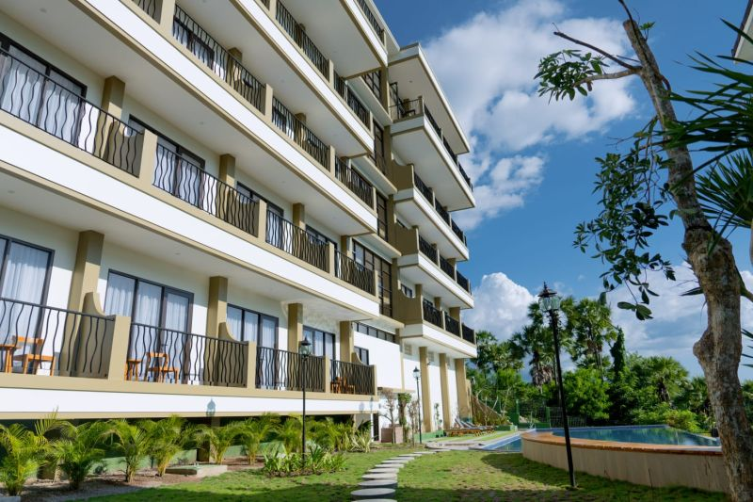

Flamingo Waecicu Hotel is one of the hotels used by Singaporean delegates to stay during the 42nd ASEAN Summit in Labuan Bajo, West Manggarai, East Nusa Tenggara, on 9—11 May 2023. (ANTARA/HO-Flamingo Waecicu Hotel)

